Key Learning at Scargill Primary School - National Curriculum (Essential) & Key Learning (Guidance)
 | Reception |  | KS1 |  | LKS2 |  | UKS2
National Curriculum | The development of children’s artistic and cultural awareness supports their imagination and creativity. It is important that children have regular opportunities to engage with the arts, enabling them to explore and play with a wide range of media and materials. The quality and variety of what children see, hear and participate in is crucial for developing their understanding, self-expression, vocabulary and ability to communicate through the arts. The frequency, repetition and depth of their experiences are fundamental to their progress in interpreting and appreciating what they hear, respond to and observe.  ELG: Creating with Materials  Children at the expected level of development will:  - Safely use and explore a variety of materials, tools and techniques, experimenting with colour, design, texture, form and function.  - Share their creations, explaining the process they have used.  - Make use of props and materials when role playing characters in narratives and stories. |  | KS1: Pupils should be taught:  - To develop their techniques, including their control and their use of materials, with creativity, experimentation, and an increasing awareness of different kinds of art, craft and design. |  | KS2: Pupils should be taught:  - To use a range of materials creatively to design and make products.  - To use drawing, painting and sculpture to develop and share their ideas, experiences and imagination.
Generating Ideas | - Choosing tools, experimenting with tools and techniques.  - Selecting, changing and arranging joining to create a sculpture.  - Choosing and arranging for collage | - Begin to generate ideas from a wider range of stimuli, exploring different media and techniques.  - Explore their own ideas using a range of media. |  | - Generate ideas from a range of stimuli, using research and evaluation of techniques to develop their ideas and plan more purposefully for an outcome.  - Generate ideas from a range of stimuli and carry out simple research and evaluation as part of the making process. |  | - Draw upon their experience of creative work and their research to develop their own starting points for creative outcomes.  - Develop ideas more independently from their own research. Explore and record their plans, ideas and evaluations to develop their ideas towards an outcome.
Sketchbooks |  | - Experiment in sketchbooks, using drawing to record ideas. Use sketchbooks to help make decisions about what to try out next.  - Use sketchbooks to explore ideas in an open-ended way. |  | - Use sketchbooks purposefully to improve understanding, develop ideas and plan for an outcome.  - Use sketchbooks for a wider range of purposes, for example recording things using drawing and annotations, planning and taking next steps in a making process. |  | - Using a systematic and independent approach, research, test and develop ideas and plans using sketchbooks.  - Confidently use sketchbooks for purposes including recording observations and research, testing materials and working towards an outcome more independently.
Making Skills (including formal elements) | - Printing techniques, patterns (repeat and random), printing with different surfaces, mono-printing.  - Choosing, arranging and sticking collage, cutting and tearing paper and shapes.  - Exploring clay (pulling, pinching, twisting and rolling, burrowing, prodding, poking)  - Sculpting using boxes and card.  - Handling and describing textiles, cutting and joining, sewing, fraying, stretching, colouring textiles (food colouring), creating textiles through wrapping.  - Using thick and thin brushes, moving paint in different ways, using other tools for painting, using and describing colour (primary and some secondary), tone and shade, dilution.  - Making and describing lines, changing lines, collecting different lines, using different lines together, using lines to describe texture and how they feel and finding different lines in a picture. | Drawing  - Use a range of drawing materials such as pencils, chalk, charcoal, pastels, felt tips and pens.  - Develop observational skills to look closely and reflect surface texture through mark-making.  - To explore mark making using a range of tools; being able to create a diverse and purposeful range of marks through experimentation building skills and vocabulary.  - Further develop mark-making within a greater range of media, demonstrating increased control.  - Develop observational skills to look closely and reflect surface texture through mark-making.  - Experiment with drawing on different surfaces and begin to explore tone using a variety of pencil grades (HB, 2B, 4B) to show form, drawing light/dark lines, patterns and shapes.  Painting and Mixed Media  - Begin to develop some control when painting, applying knowledge of colour and how different media behave eg adding water to thin paint  - Mix different hues of primary and secondary colours by using different amounts of each starting colour or by adding water.  - Make choices about which materials to use for collage based on colour, texture, shape and pattern. Experiment with overlapping and overlaying materials to create interesting effects.  - Experiment with paint, using a wide variety of tools (eg brushes, sponges, fingers) to apply paint. Investigate colour mixing.  - Play with combinations of materials to create simple collage effects. Select materials based on their properties, eg shiny, soft.  Sculpture and 3D  - Develop understanding of 3D forms to construct and model simple forms using a range of materials.  - Use hands and tools with confidence when cutting, shaping and joining paper, card and malleable materials.  - Develop basic skills for shaping and joining clay, including exploring surface texture.  - Use their hands to manipulate a range of modelling materials.  - Create 3D forms to make things from their imagination or recreate things they have seen.  Craft and Design  - Respond to a simple design brief with a range of ideas.  - Apply skills in cutting, arranging and joining a range of materials to include card, felt and cellophane.  - Experiment with techniques when trying out design ideas.  Follow a plan for a making process, modifying and correcting things and knowing when to seek advice. |  | Drawing  - Apply observational skills, showing a greater awareness of composition and demonstrating the beginnings of an individual style.  - Use growing knowledge of different drawing materials, combining media for effect.  - Demonstrate greater control over drawing tools to show awareness of proportion and perspective, continuing to develop use of tone and more intricate mark making.  - Confidently use of a range of materials, selecting and using these appropriately with more independence.  - Draw with expression and begin to experiment with gestural and quick sketching.  - Developing drawing through further direct observation, using tonal shading and starting to apply an understanding of shape to communicate form and proportion.  Painting and Mixed Media  - Select and use a variety of painting techniques, including applying their drawing skills, using their knowledge of colour mixing and making choices about suitable tools for a task eg choosing a fine paintbrush for making detailed marks.  - Mix colours with greater accuracy and begin to consider how colours can be used expressively. Explore contrasting and complimentary colours.  - Modify chosen collage materials in a range of ways eg by cutting, tearing, re-sizing or overlapping. In sketchbooks, use collage as a means of collecting ideas.  - Explore the way paint can be used in different ways to create a variety of effects, eg creating a range of marks and textures in paint.  - Develop greater skill and control when using paint to depict forms, eg beginning to use tone to create 3D effects.  - Work selectively, choosing and adapting collage materials to create contrast and considering overall composition.  Sculpture and 3D  - Use more complex techniques to mould and form malleable materials, such as the coil pot technique in clay and adding detailed surface decoration.  - Show an understanding of appropriate finish and present work to a good standard.  - Respond to a stimulus and begin to make choices about materials used to work in 3D  - Able to plan and think through the making process to create 3D forms using a range of materials.  - Shape materials for a purpose, positioning and joining materials in new ways (tie, bind, stick, fold).  - Experiment with combining found objects and recyclable material to create sculpture.  Craft and Design  - Learn new making techniques, comparing these and making decisions about which method to use to achieve a particular outcome.  - Design and make art for different purposes and begin to consider how this works in creative industries.  - Learn a new making technique (papermaking) and apply it as part of their own project.  - Investigate the history of a craft technique and share that knowledge in a personal way.  - Design and make creative work for different purposes, evaluating the success of the techniques used. |  | Drawing  - Draw expressively in their own personal style and in response to their choice of stimulus, showing the ability to develop a drawing independently.  - Apply new drawing techniques to improve their mastery of materials and techniques  - Push the boundaries of mark-making to explore new surfaces, e.g. drawing on clay, layering media and incorporating digital drawing techniques.  - To use a broader range of stimulus to draw from, such as architecture, culture and photography. Begin to develop drawn ideas as part of an exploratory journey.  - Apply known techniques with a range of media, selecting these independently in response to a stimulus.  - Draw in a more sustained way, revisiting a drawing over time and applying their understanding of tone, texture, line, colour and form.  Painting and Mixed Media  - Manipulate paint and painting techniques to suit a purpose, making choices based on their experiences. Work in a sustained way over several sessions to complete a piece.  - Analyse and describe how colour is used in other artists’ work.  Consider materials, scale and techniques when creating collage and other mixed media pieces. Create collage in response to a stimulus and work collaboratively on a larger scale.  - Apply paint with control in different ways to achieve different effects, experimenting with techniques used by other artists and applying ideas to their own artworks eg making choices about painting surfaces or mixing paint with other materials.  - Develop a painting from a drawing or other initial stimulus.  Add collage to a painted, printed or drawn background for effect.  Explore how collage can extend original ideas. Combine digital effects with other media.  Sculpture and 3D  - Uses personal plans and ideas to design and construct more complex sculptures and 3D forms.  - Combine materials and techniques appropriately to fit with ideas.  - Confidently problem-solve, edit and refine to create desired effects and end results.  - Investigate scale when creating forms in three dimensions.  - Explore a greater range of materials to create 3D forms eg.wire and found materials  - Plan a sculpture, developing an idea in 2D into a three-dimensional piece.  - Persevere when constructions are challenging and work to problem solve more independently.  Craft and Design  Draw upon their experience of creative work and their research to develop their own starting points for creative outcomes.  Develop ideas more independently from their own research. Explore and record their plans, ideas and evaluations to develop their ideas towards an outcome.
Knowledge of artists | Talk about artists they have seen and explain why they like or dislike their work.  Aboriginal work, patterns on fabrics and wallpaper, illustrators, folk weave, patchwork quilt designs | - Talk about art they have seen using some appropriate subject vocabulary. Be able to make links between pieces of art.  - Describe similarities and differences between practices in Art and design, e.g. between painting and sculpture, and link these to their own work |  | - Use subject vocabulary confidently to describe and compare creative works.  - Use their own experiences of techniques and making processes to explain how art works may have been made.  - Use subject vocabulary to describe and compare creative works. Use their own experiences to explain how art works may have been made. |  | - Describe, interpret and evaluate the work, ideas and processes used by artists across a variety of disciplines, being able to describe how the cultural and historical context may have influenced their creative work.  - Research and discuss the ideas and approaches of artists across a variety of disciplines, being able to describe how the cultural and historical context may have influenced their creative work
Evaluating and analysing | Discussing work with peers and teachers.  Explaining why...  Telling the teacher what their artwork is about...  Talk about choices... | - Explain their ideas, opinions about their own, and other’s artwork, giving reasons. Begin to talk about how they could improve their own work.  - Describe and compare features of their own and others’ artwork. |  | - Build a more complex vocabulary when discussing their own and others’ art.  - Evaluate their work more regularly and independently during the planning and making process.  - Confidently explain their ideas and opinions about their own and other’s art work, giving reasons. Use sketchbooks as part of the problem-solving process and make changes to improve their work. |  | - Give reasoned evaluations of their own and others work which takes account of context and intention.  - Independently use their knowledge of tools, materials and processes to try alternative solutions and make improvements to their work.  - Discuss the processes used by themselves and by other artists, and describe the particular outcome achieved.  - Use their knowledge of tools, materials and processes to try alternative solutions and make improvements to their work.
Artist(s) covered | Kandisky, Munch, Hockney, Klee, Van Gough, Picasso, Ayres, Derain, Monet, Bonnard, Seurat, Blake, Matisse, Moore, Goldsworthy, Long, | 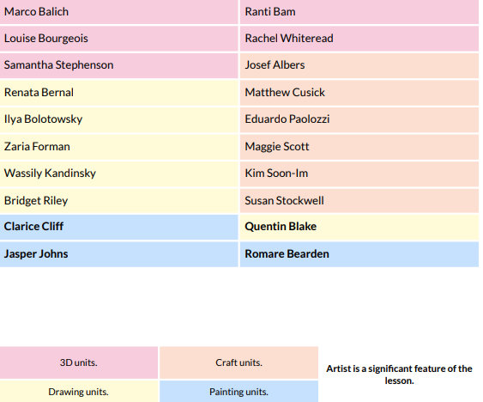 |  | 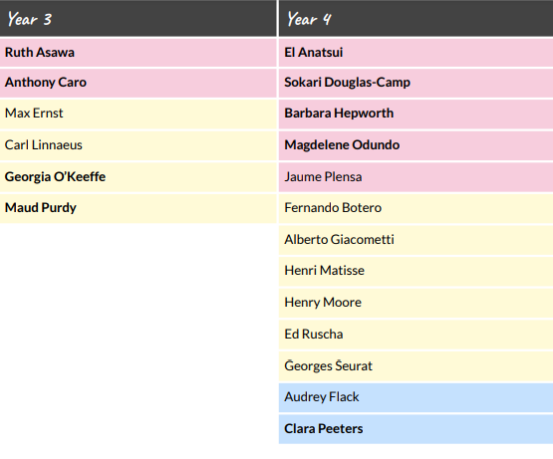 |  | 