**Our RHE Work**

At Scargill, we use Jigsaw, the mindful approach PSHE (Personal, Social and Health Education) to deliver our teaching and learning of PSHE.

Jigsaw PSHE is a comprehensive and completely original Scheme of Work (lesson plans) for the whole primary school. The Jigsaw teaching materials integrate Personal, Social, Health Education (PSHE), emotional literacy, social skills, mindfulness, and spiritual development in a whole-school approach. The expectations of the DfE Relationships and Health Education guidance are woven throughout Jigsaw but specifically covered in the Relationships and Healthy Me Puzzles (units), with puberty and human reproduction being taught in the Changing Me Puzzle.

From September 2020, Relationships and Health Education are compulsory in all primary schools in England. For primary aged children this includes curriculum content under two headings (DfE 2019):

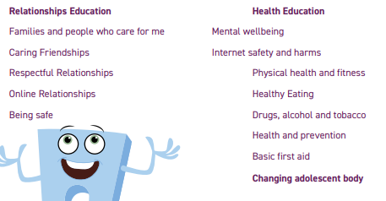

The Jigsaw PSHE lessons aim to give children their entitlement to information about relationships, puberty and human reproduction, appropriate to their ages and stages of development. This work is treated in a matter-of-fact and sensitive manner and helps children to cope with change, including puberty, and to learn about healthy relationships. There are six Puzzles (units), each with six lessons:

Being me in My World

Celebrating Difference

Dreams and Goals

Healthy Me

Relationships

Changing Me.

These are sequenced from the beginning to the end of the school year. The Relationships and Changing Me Puzzles are taught in the Summer Term.

Jigsaw’s ‘Changing Me’ unit is taught over a period of 6 weeks, usually in the second half of the summer term. Each year group will be taught appropriate to their age and developmental stage, building on the previous years’ learning. Please note: at no point will a child be taught something that is inappropriate; and if a question from a child arises and the teacher feels it would be inappropriate to answer (for example, because of its mature or explicit nature), the child will be encouraged to ask his/her parents or carers at home. The question will not be answered to the child or class if it is outside the remit of that year group’s agreed programme.

The Changing Me Puzzle includes, in every year group, a few lessons to help children understand the changes puberty brings and how human reproduction happens. There is a very serious safeguarding aspect to this work and obviously the younger year groups are not looking at these issues directly and explicitly, but rather learning correct terminology for body parts and doing the foundation work for later year groups. The Years 5 and 6 lessons look more fully at puberty and human reproduction.

All lessons are taught using correct terminology, child-friendly language and diagrams. As a school, we will carefully check the content each year and make any adaptations we feel are appropriate in line with our school policies.

We hope you will agree with us that this work is vitally important for children, that it needs to be done age-appropriately and that the Jigsaw Programme gives us a secure framework in which to do this.

However, we do as always want to work in partnership with parents and carers, and your right of withdrawal are detailed in our policy.

We hope you, like us, will see the materials in Jigsaw as educationally sound and beneficial to our children, helping to safeguard them, and will look forward to sharing them with you and answering any questions you may have.