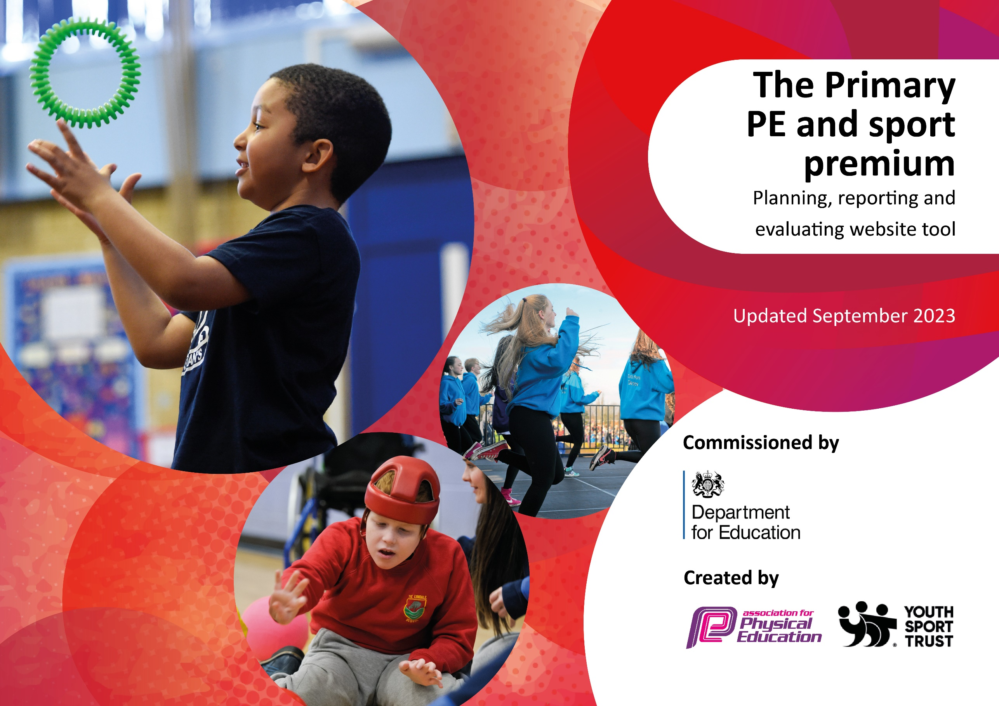

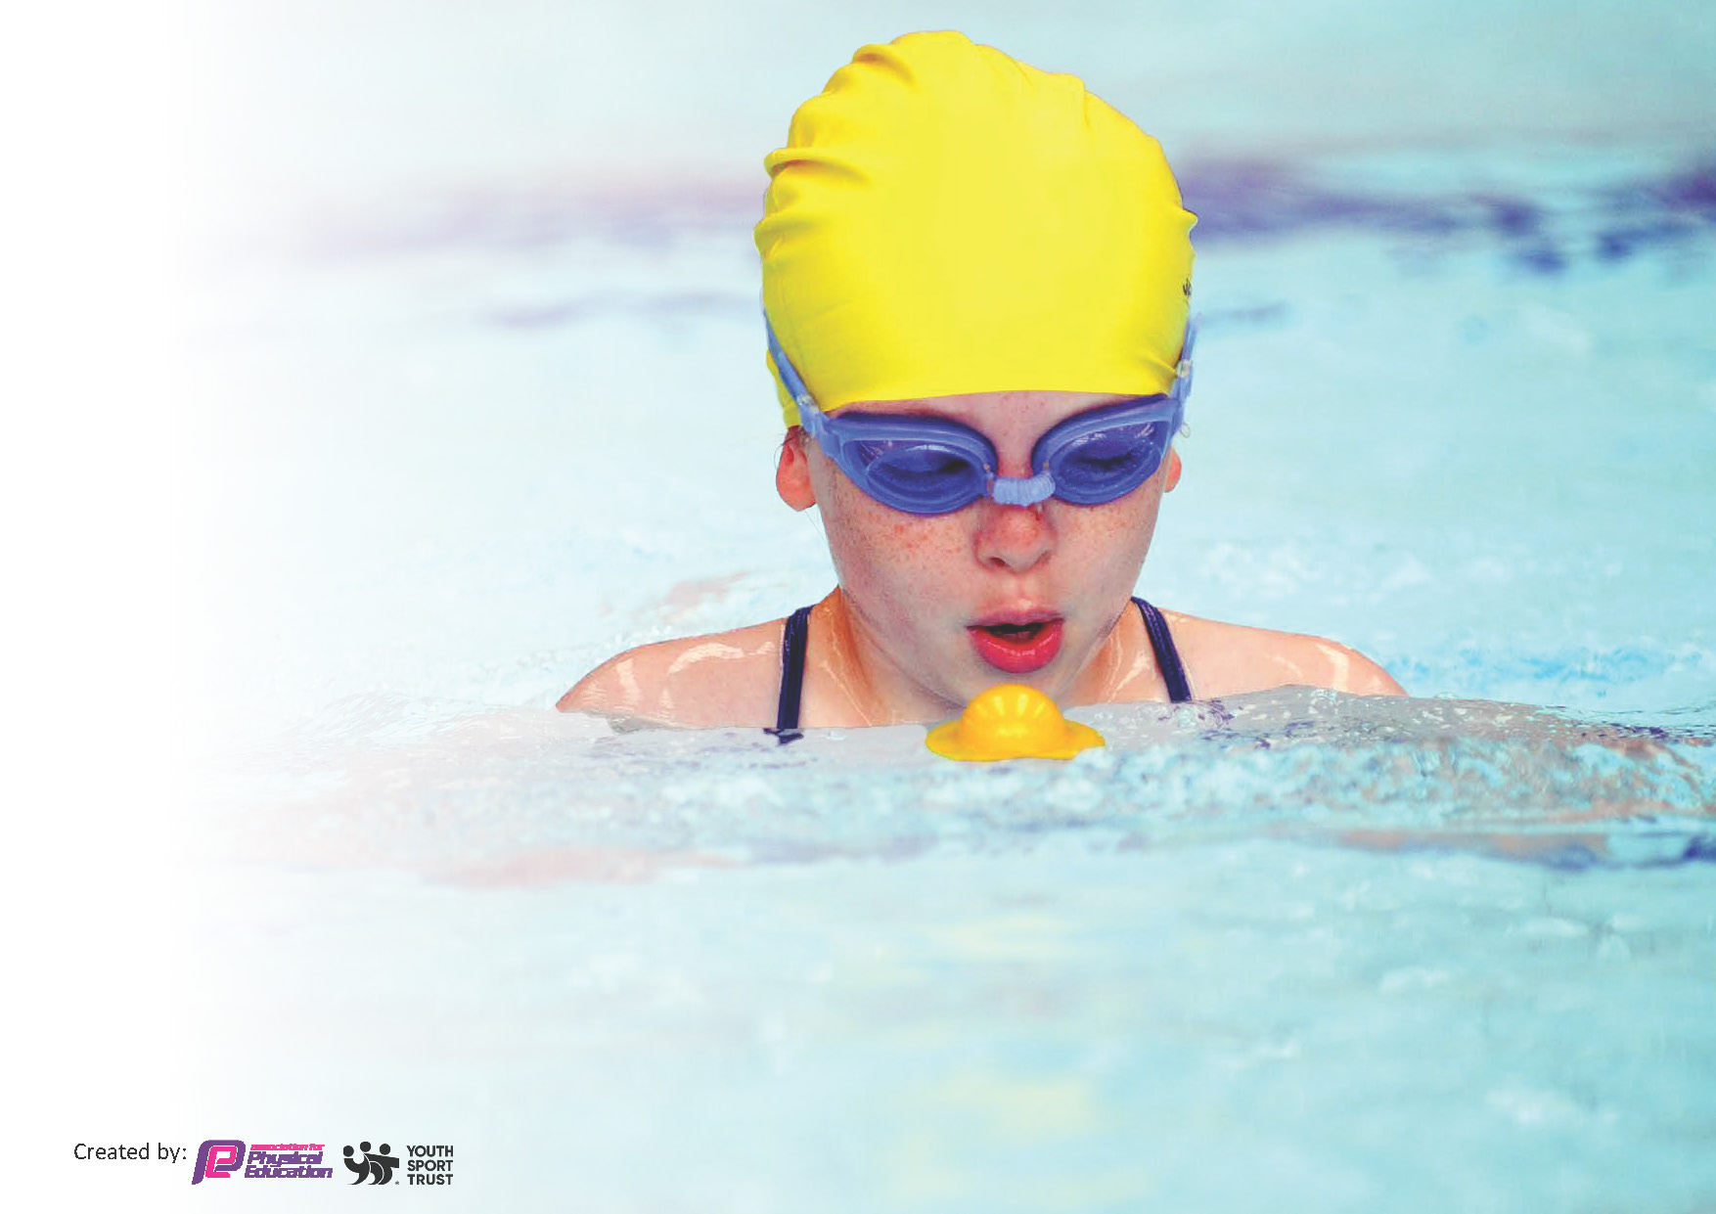
This template can be used for multiple purposes:
by:
- It enables schools to effectively plan their use of the Primary PE and sport premium
- It helps schools to meet the requirements (as set out in guidance) to publish information on their Primary PE and sport premium
- It will be an effective document to support Ofsted inspections enabling schools to evidence progress in Physical Education (PE) and evidence swimming attainment, which forms part of the PE National Curriculum. We would recommend schools consider
the Intent, Implementation and Impact of any spend, as examined within the Education Inspection Framework.

It is important that your grant is used effectively and based on school need.

Schools must use the funding to make additional and sustainable
improvements to the quality of the PE, School Sport and Physical Activity (PESSPA)
they offer. This means that you should use the Primary PE and sport premium to:

- Build capacity and capability within the school to ensure that improvements made now will benefit pupils joining the school in future years
- Develop or add to the PESSPA activities that your school already offers.

The Primary PE and sport premium should not be used to fund capital spend projects; the school’s core budget should fund these. Further detail on capital expenditure can be found in the updated Primary PE and sport premium guidance.

The Primary PE and sport premium guidance, outlines 5 key priorities that funding should be used towards. It is not

necessary that spending has to meet all the key priorities, you should select the priorities that you aim to use any funding towards.

Although completing this template is not a requirement for schools, schools are required to publish details of how they spend this funding. Schools must also outline what the impact this funding has had on pupils’ PE and sport participation and attainment and how any spending will be sustainable in the future. All funding must be spent by 31st July 2026.

The Department for Education has worked closely with the Association for Physical Education (afPE) and the Youth Sport Trust (YST) to develop this template and encourages schools to use it. This template is an effective way of meeting the reporting requirements of the Primary PE and sport premium.
Review of last year’s spend and key achievements (2024/2025)

We recommend you start by reflecting on the impact of current provision and reviewing your previous spend.

Activity/Action | Impact | Comments
- To increase participation in sporting activities by introducing sporting activities at lunchtime.  - The increased opportunities children have to compete in competitive sport across the academic year. | - It has been noted that more children have been staying active at playtime and lunchtime and this is due to the activities that the Sports Ambassadors were providing. The Sports Ambassadors received training from AM Sports to equip them with the knowledge and skills to run a variety of games. Ambassadors used a register system to help ensure as many children took part as possible. | - Sports Ambassadors are to take up a more captain based roll and Sports leaders are to be trained up and used initially on the KS1 playground, moving on to working in a designated area in the KS2 playground.  - Despite the increased opportunities, this will remain a high priority for this academic year. We have created a better ensuring events are organized in advance and will try to meet a target of 75% of children taking part in a sporting event this year. The school online calendar has enabled bookings to be checked in advance for clashes.
 | - Children across school had more opportunities to engage in competitive sport through Erewash School Sport Partnership (ESSP) events and had some success, such as the Y5/6 Football and netball teams progressing taking part in many friendly matches. Also the school won the ESSP Cross Country event and a Girls football competition. All Y6 children had the opportunity to attend a sports event last year.

Key priorities and Planning
This planning template will allow schools to accurately plan their spending.

Action – what are you planning to do | Who does this action impact? | Key indicator to meet | Impacts and how sustainability will be achieved? | Cost linked to the action
To continue work increase participation in sporting activities by building on work done towards sporting activities at lunchtime. | Sports Ambassadors – They will be ensuring the sporting activities are accessed by as many children as possible. They will also be helping choose activities that their peers would enjoy.  Midday supervisors and AM Sport coaches – They will monitor and engage with the children participating in the sporting activities.  Pupils – They will be taking part in the activities.  PE Lead – To assist sports leaders and AM sports coach in organising and monitoring lunch time games and tracking participation, | Key Indicator 2: The engagement of all pupils in regular physical activity. The Chief Medical Officer guidelines recommend that all children and young people aged 5 to 18 engage in at least 60 minutes of physical activity per day, of which 30 minutes should be in school.  Key Indicator 4: Broader experience of a range of sports and activities offered to all pupils. | All children will have opportunities to represent their class and engage in physical activity at play and lunchtimes with a wide range of activities available to them. This will support more pupils in meeting their daily physical goal. | £7800 – Cost for AM Sports. £200 for 2x afternoons [Tuesday and Wednesday]).
To increase participation in sporting activities by increasing sporting activities and clubs for pupils to attend before and after school. | Class Teachers and AM Sport coaches – They will be leading the extra-curricular activities.  Pupils – They will be taking part in the activities. | Key Indicator 2: The engagement of all pupils in regular physical activity. The Chief Medical Officer guidelines recommend that all children and young people aged 5 to 18 engage in at least 60 minutes of physical activity per day, of which 30 minutes should be in school.  Key Indicator 4: Broader experience of a range of sports and activities offered to all pupils. | All children will have an increased amount of opportunities to participate in a wide range of sporting activities before and after school which will support more pupils in meeting their daily physical goal. These clubs will be run by class teachers and AM Sport coaches. | £7800 – Cost for AM Sports. £200 for 2x afternoons [Tuesday and Wednesday]). (Already costed for)
To upskill the Sports Ambassadors to lead lunchtime sporting activities. | AM Sports and PE Lead – They will be training and upskilling Mini Leaders.  Sports Ambassadors – They will have the confidence to provide different sporting activities to other children across school. | Key Indicator 2: The engagement of all pupils in regular physical activity. The Chief Medical Officer guidelines recommend that all children and young people aged 5 to 18 engage in at least 60 minutes of physical activity per day, of which 30 minutes should be in school.  Key Indicator 3: The profile of PE and sport is raised across the school as a tool for whole-school improvement. | Sports Ambassadors will be equipped with the knowledge, confidence and skills to in leading sporting activities during lunchtimes whilst becoming role models for sport and PE across school. This will help ensure more children will have opportunities to access a wide range of sporting activities at lunchtimes. | £7800 – Cost for AM Sports. £200 for 2x afternoons [Tuesday and Wednesday]). (Already costed for)
To support teachers in delivering PE lessons by providing CPD. | PE Lead – They will be upskilling the teaching staff across school.  AM Sports coaches – They will be upskilling the teaching staff across school.  Teachers – They will have increased knowledge, confidence and skills to deliver high quality PE lessons.  Pupils – They will have access to high quality PE lessons. | Key Indicator 1: Increased confidence, knowledge and skills of all staff in teaching PE and sport.  Key Indicator 3: The profile of PE and sport is raised across the school as a tool for whole-school improvement. | Teaching staff, who are less confident in delivering PE lessons, will receive high quality CPD (through Staff Meeting) and support (through team teaching and mentoring) to increase their confidence in delivering the PE curriculum and extra-curricular activities. | £7800 – Cost for AM Sports. £200 for 2x afternoons [Tuesday and Wednesday]). (Already costed for)
To participate and increase the opportunities children get in competing in competitive sports through participating in inter competitions through Erewash School Sports Partnership (ESSP) | ESSP coaches – They will be organising and running the different sporting events.  Pupils – They will have opportunities to access competitive support and a chance to represent their school.  -They will want to represent school in sporting events.  Parents – They will have the opportunity to see their child represent the school in different sporting activities. | Key Indicator 2: The engagement of all pupils in regular physical activity. The Chief Medical Officer guidelines recommend that all children and young people aged 5 to 18 engage in at least 60 minutes of physical activity per day, of which 30 minutes should be in school.  Key Indicator 3: The profile of PE and sport is raised across the school as a tool for whole-school improvement.  Key Indicator 4: Broader experience of a range of sports and activities offered to all pupils.  Key Indicator 5: Increased participation in competitive sport. | All children across the school will have opportunities to represent the school in Erewash School Sports Partnership competitions and festivals. This will help promote healthy competitive sport but in an inclusive manner whilst teaching the children the importance of Sportsmanship. | £4,200 – Cost for Erewash School Sport Partnership affiliation.  £1,500 – Cost for transportation to attend the different ESSP competitions and festivals.  £500 – Cost for sports kits to ensure children feel proud to represent Scargill.  £1000 – Staffing cover costings for staff members attending sporting events during school hours.
To implement intra-competitions across school at lunchtimes. | Class Teachers – They will be promoting intra school competitions within their cohorts.  Pupils – They will have opportunities to access competitive support in a safe and inclusive environment. Mini Leaders and sports ambassadors will work together to ensure all children have the opportunity to participate.  Sports ambassadors to do a regular register and surveys to ensure a range of activities take place and use the information to target children yet to attend. | Key Indicator 2: The engagement of all pupils in regular physical activity. The Chief Medical Officer guidelines recommend that all children and young people aged 5 to 18 engage in at least 60 minutes of physical activity per day, of which 30 minutes should be in school.  Key Indicator 4: Broader experience of a range of sports and activities offered to all pupils.  Key Indicator 5: Increased participation in competitive sport. | All children across school will have ample opportunities to participate in competitive sport though intra-competitions. These will be embedded into the PE curriculum to enable children opportunities to showcase their skills and knowledge of different units whilst supporting more pupils in meeting their daily physical goal. | £7800 – Cost for AM Sports. £200 for 2x afternoons [Tuesday and Wednesday]). (Already costed for)
To subscribe to GetSet4PE scheme to support confidence in PE teaching and learning. | Class Teachers – Confidence to deliver high quality PE lessons.  Pupils – They will have access to high quality PE lessons. | Key Indicator 1: Increased confidence, knowledge and skills of all staff in teaching PE and sport. | Children experience high quality PE through a wide range of sporting activities with a progression of knowledge and skills in each lesson. There is an increase in confidence and engagement from children and staff through using the scheme. | £460 – Cost for access to the Get Set 4 PE scheme.
To increase the confidence of children riding a bike before they leave Primary School. | ESSP coaches – They will be organising and running the Bikeability course.  Pupils – They will take part in the Bikeability course. | Key Indicator 2: The engagement of all pupils in regular physical activity.  Key Indicator 4: Broader experience of a range of sports and activities offered to all pupils. | Children achieve a key life skill in being able to ride a bike with confidence before they leave for Secondary School. | £4,200 - Cost for Erewash School Sport Partnership affiliation – Bikeability is part of the package. (Already costed for)  £330 – Balance bike training for EYFS.
To regularly inform the school community of sporting achievement and opportunities. | PE Lead – They will regularly inform the school community of sporting success through X(Twitter) and updates in the school newsletter. | Key Indicator 3: The profile of PE and sport is raised across the school as a tool for whole-school improvement. | All school stakeholders will have a better understanding of the sporting opportunities to children and will help raise the profile of PE across the school.
To purchase any necessary PE equipment/resource to support lessons and clubs. | Teachers – They will have more resources to provide high quality PE lessons and other sporting activity.  Pupils – They will have more resources to access when participating in sporting activity. | Key Indicator 3: The profile of PE and sport is raised across the school as a tool for whole-school improvement. | Children and teachers will have access to the appropriate equipment to ensure high quality PE is taking place and the opportunity to practice the correct sporting skills using the correct equipment. | £3,000 – Cost for purchasing new equipment to link to the PE curriculum and provide a wide range of sporting activities.

Key achievements 2025-2026
This template will be completed at the end of the academic year and will showcase the key achievements schools have made with their Primary PE and sport premium spending.

Activity/Action | Impact | Comments

Swimming Data
Meeting National Curriculum requirements for swimming and water safety. To be filled out at the end of the year.
Priority should always be given to ensuring that pupils can perform safe self-rescue even if they do not fully meet the first two requirements of the National Curriculum programme of study

Question84 | Stats: | Further context  Relative to local challenges
What percentage of your current Year 6 cohort can swim competently, confidently and proficiently over a distance of at least 25 metres?
What percentage of your current Year 6 cohort can use a range of strokes effectively [for example, front crawl, backstroke, and breaststroke]?

What percentage of your current Year 6 cohort are able to perform safe self-rescue in different water-based situations?
If your schools swimming data is below national expectation, you can choose to use the Primary PE and sport premium to provide additional top-up sessions for those pupils that did not meet National Curriculum
requirements after the completion of core lessons. Have you done this?
Have you provided CPD to improve the knowledge and confidence of staff to be able to teach swimming and water safety?

Signed off by:

Head Teacher: | Sarah Hallsworth & Malc Hetherington
Subject Leader or the individual responsible for the Primary PE and sport premium: | William Askew
Governor:
Date: | 18.09.2025

