
Scargill Church of England Primary School

Supporting Children in School with Medical Needs Policy

Governor approval |  |  | Date: | September 2024
Review date: September 2025

Statement of intent
The governing board of Scargill CE Primary School has a duty to ensure arrangements are in place to support pupils with medical conditions. The aim of this policy is to ensure that all pupils with medical conditions, in terms of both physical and mental health, receive appropriate support allowing them to play a full and active role in school life, remain healthy, have full access to education (including school trips and physical education) and achieve their academic potential.

Scargill CE Primary School believes it is important that parents/carers of pupils with medical conditions feel confident that the school provides effective support for their child’s medical condition, and that pupils feel safe in the school environment.

There are also social and emotional implications associated with medical conditions. Pupils with medical conditions can develop emotional disorders, such as self-consciousness, anxiety and depression, and be subject to bullying. This policy aims to minimise the risks of pupils experiencing these difficulties.

Long-term absences as a result of medical conditions can affect educational attainment, impact integration with peers, and affect wellbeing and emotional health. This policy contains procedures to minimise the impact of long-term absence and effectively manage short-term absence.

Some pupils with medical conditions may be considered to be disabled under the definition set out in the Equality Act 2010. The school has a duty to comply with the Act in all such cases.

In addition, some pupils with medical conditions may also have SEND and have an education, health and care (EHC) plan collating their health, social and SEND provision. For these pupils, compliance with the DfE’s ‘Special educational needs and disability code of practice: 0 to 25 years’ and the school’s SEND Policy will ensure compliance with legal duties.

To ensure that the needs of our pupils with medical conditions are fully understood and effectively supported, we consult with health and social care professionals, pupils and their parents/carers.

Signed by:
Headteacher Date:
Chair of governors Date:

Legal framework
  - This policy has due regard to legislation including, but not limited to, the following:
- The Children and Families Act 2014
- The Education Act 2002
- The Education Act 1996 (as amended)
- The Children Act 1989
- The National Health Service Act 2006 (as amended)
- The Equality Act 2010
- The Health and Safety at Work etc. Act 1974
- The Misuse of Drugs Act 1971
- The Medicines Act 1968
- The School Premises (England) Regulations 2012 (as amended)
- The Special Educational Needs and Disability Regulations 2014 (as amended)
- The Human Medicines (Amendment) Regulations 2017
  - This policy has due regard to the following guidance:
- DfE (2015) ‘Special educational needs and disability code of practice: 0-25 years’
- DfE (2015) ‘Supporting pupils at school with medical conditions’
- DfE (2000) ‘Guidance on first aid for schools’
- Ofsted (2015) ‘The common inspection framework: education, skills and early years’
- Department of Health (2017) ‘Guidance on the use of adrenaline auto-injectors in schools’
  - This policy has due regard to the following school policies:
- Administering Medication Policy
- First Aid Policy
- SEND Policy
- Asthma Policy
- Complaints Procedure Policy

The role of the governing board
  - The governing board:
- Is legally responsible for fulfilling its statutory duties under legislation.
- Ensures that arrangements are in place to support pupils with medical conditions.
- Ensures that pupils with medical conditions can access and enjoy the same opportunities as any other pupil at the school.
- Works with the LA, health professionals, commissioners and support services to ensure that pupils with medical conditions receive a full education.
- Ensures that, following long-term or frequent absence, pupils with medical conditions are reintegrated effectively.
- Ensures that the focus is on the needs of each pupil and what support is required to support their individual needs.
- Instils confidence in parents/carers and pupils in the school’s ability to provide effective support.
- Ensures that all members of staff are properly trained to provide the necessary support and are able to access information and other teaching support materials as needed.
- Ensures that no prospective pupil is denied admission to the school because arrangements for their medical condition have not been made.
- Ensures that pupils’ health is not put at unnecessary risk. As a result, the board holds the right to not accept a pupil into school at times where it would be detrimental to the health of that pupil or others to do so, such as where the child has an infectious disease.
- Ensures that policies, plans, procedures and systems are properly and effectively implemented.
  - Head of School holds overall responsibility for implementation of this policy.

The role of the head of school
  - The head of school:
- Ensures that this policy is effectively implemented with stakeholders.
- Ensures that all staff are aware of this policy and understand their role in its implementation.
- Ensures that a sufficient number of staff are trained and available to implement this policy and deliver against all individual healthcare plans (IHPs), including in emergency situations.
- Considers recruitment needs for the specific purpose of ensuring pupils with medical conditions are properly supported.
- Has overall responsibility for the development of IHPs.
- Ensures that staff are appropriately insured and aware of the insurance arrangements.
- Contacts the school nursing service where a pupil with a medical condition requires support that has not yet been identified.

The role of parents/carers
  - Parents/carers:
- Notify the school if their child has a medical condition.
- Provide the school with sufficient and up-to-date information about their child’s medical needs.
- Are involved in the development and review of their child’s IHP.
- Carry out any agreed actions contained in the IHP.
- Ensure that they, or another nominated adult, are contactable at all times.

The role of pupils
  - Pupils:
- Are fully involved in discussions about their medical support needs.
- Contribute to the development of their IHP.
- Are sensitive to the needs of pupils with medical conditions.

The role of school staff
  - School staff:
- May be asked to provide support to pupils with medical conditions, including the administering of medicines, but are not required to do so.
- Take into account the needs of pupils with medical conditions in their lessons when deciding whether or not to volunteer to administer medication.
- Receive sufficient training and achieve the required level of competency before taking responsibility for supporting pupils with medical conditions.
- Know what to do and respond accordingly when they become aware that a pupil with a medical condition needs help.

The role of clinical commissioning groups (CCGs)
  - CCGs:
- Ensure that commissioning is responsive to pupils’ needs, and that health services are able to cooperate with schools supporting pupils with medical conditions.
- Make joint commissioning arrangements for education, health and care provision for pupils with SEND.
- Are responsive to LAs and schools looking to improve links between health services and schools.
- Provide clinical support for pupils who have long-term conditions and disabilities.
- Ensure that commissioning arrangements provide the necessary ongoing support essential to ensuring the safety of vulnerable pupils.

The role of other healthcare professionals
  - Other healthcare professionals, including GPs and paediatricians:
- Notify the school nurse when a child has been identified as having a medical condition that will require support at school.
- Provide advice on developing IHPs.
- May provide support in the school for children with particular conditions, e.g. asthma, diabetes and epilepsy.

The role of providers of health services
  - Providers of health services co-operate with the school, including ensuring communication, liaising with the school nurse and other healthcare professionals, and participating in local outreach training.

Admissions
  - No child is denied admission to the school or prevented from taking up a school place because arrangements for their medical condition have not been made.
  - A child may only be refused admission if it would be detrimental to the health of the child to admit them into the school setting.

Notification procedure
  - When the school is notified that a pupil has a medical condition that requires support in school, a meeting must be arranged with parents/carers, healthcare professionals and the pupil, with a view to discussing the necessity of an IHP
  - The school does not wait for a formal diagnosis before providing support to pupils. Where a pupil’s medical condition is unclear, or where there is a difference of opinion concerning what support is required, a judgement is made by the head of school based on all available evidence (including medical evidence and consultation with parents/carers).
  - For a pupil starting at the school in a September uptake, arrangements are in place prior to their introduction and informed by their previous institution.
  - Where a pupil joins the school mid-term or a new diagnosis is received, arrangements are put in place within two weeks.

Staff training and support
  - Any staff member providing support to a pupil with medical conditions receives suitable training.
  - Staff do not undertake healthcare procedures or administer medication without appropriate training.
  - Training needs are assessed through the development and review of IHPs, on a yearly basis for all school staff, and when a new staff member arrives.
  - Through training, staff have the requisite competency and confidence to support pupils with medical conditions and fulfil the requirements set out in IHPs. Staff understand the medical condition(s) they are asked to support, their implications, and any preventative measures that must be taken.
  - A first-aid certificate does not constitute appropriate training for supporting pupils with medical conditions.
  - Whole-school awareness training is carried out on a yearly basis for all staff, and included in the induction of new staff members.

Self-management
  - Following discussion with parents/carers, pupils who are competent to manage their own health needs and medicines are encouraged to take responsibility for self-managing their medicines and procedures. This is reflected in their IHP.
  - Where possible, pupils are allowed to carry their own medicines and relevant devices.
  - Where it is not possible for pupils to carry their own medicines or devices, they are held in suitable locations that can be accessed quickly and easily.
  - If a pupil refuses to take medicine or carry out a necessary procedure, staff will not force them to do so. Instead, the procedure agreed in the pupil’s IHP is followed. Following such an event, parents/carers are informed so that alternative options can be considered.

Individual healthcare plans (IHPs)
  - The school, healthcare professionals and parent/carer(s) agree, based on evidence, whether an IHP is required for a pupil, or whether it would be inappropriate or disproportionate to their level of need. If no consensus can be reached, the head of school makes the final decision.
  - The school, parent/carer(s) and a relevant healthcare professional work in partnership to create and review IHPs. Where appropriate, the pupil is also involved in the process.
  - Where a pupil has an emergency healthcare plan prepared by their lead clinician, this is used to inform the IHP.
  - IHPs are easily accessible to those who need to refer to them, but confidentiality is preserved.
  - IHPs are reviewed on at least an annual basis, or when a child’s medical circumstances change, whichever is sooner.
  - Where a pupil has an EHC plan, the IHP is linked to it or becomes part of it.
  - Where a child has SEND but does not have a statement or EHC plan, their SEND should be mentioned in their IHP.
  - Where a child is returning from a period of hospital education, alternative provision or home tuition, we work with the LA and education provider to ensure that their IHP identifies the support the child needs to reintegrate.

Managing medicines
  - In accordance with the school’s Administering Medication Policy, medicines are only administered at school when it would be detrimental to a pupil’s health or school attendance not to do so.
  - Pupils under 16 years of age are not given prescription or non-prescription medicines without their parent/carer’s written consent – except where the medicine has been prescribed to the pupil without the parent/carer’s knowledge. In such cases, the school encourages the pupil to involve their parents/carers, while respecting their right to confidentially.
  - Non-prescription medicines may be administered in the following situations:
- When it would be detrimental to the pupil’s health not to do so
- When instructed by a medical professional
  - No pupil under 16 years of age is given medicine containing aspirin unless prescribed by a doctor.
  - The school only accepts medicines that are in-date, labelled, in their original container, and that contain instructions for administration, dosage and storage. The only exception to this is insulin, which must still be in-date, but is available in an insulin pen or pump, rather than its original container.
  - All medicines are stored safely. Pupils know where their medicines are at all times and are able to access them immediately, whether in school or attending a school trip/residential visit. Where relevant, pupils are informed of who holds the key to the relevant storage facility.
  - When medicines are no longer required, they are returned to parents/carers for safe disposal. Sharps boxes are always used for the disposal of needles and other sharps.
  - Controlled drugs are stored in a non-portable container and only named staff members have access; however, these drugs are easily accessed in an emergency. A record is kept of the amount of controlled drugs held and any doses administered.
  - Staff may administer a controlled drug to a pupil for whom it has been prescribed. They must do so in accordance with the prescriber’s instructions.
  - Records are kept of all medicines administered to individual pupils – stating what, how and how much was administered, when and by whom. A record of side effects presented is also held.

Adrenaline auto-injectors (AAIs)
  - The administration of AAIs and the treatment of anaphylaxis will be carried out in accordance with the school’s Allergy Protocol
  - A Register of AAIs will be kept of all the pupils who have been prescribed an AAI to use in the event of anaphylaxis. A copy of this will be held in each classroom for easy access in the event of an allergic reaction and will be checked as part of initiating the emergency response.
  - Where a pupil has been prescribed an AAI, this will be written into their IHP.
  - Where there is any delay in contacting designated staff members, or where delay could cause a fatality, the nearest staff member will administer the AAI.
  - If necessary, other staff members may assist the designated staff members with administering AAIs, such as where the pupil needs restraining.
  - The spare AAI will only be administered to pupils at risk of anaphylaxis and where written parental consent has been gained.
  - Where a pupil who does not have a prescribed AAI appears to be having a severe allergic reaction, the emergency services will be contacted and advice sought as to whether administration of the spare AAI is appropriate.
  - Where a pupil appears to be having a severe allergic reaction, the emergency services will be contacted even if an AAI device has already been administered.
  - Where any AAIs are used, the following information will be recorded on the AAI Record:
- Where and when the reaction took place
- How much medication was given and by whom

  - In the event of a school trip, pupils at risk of anaphylaxis will have their own AAI with them and the school will give consideration to taking the spare AAI in case of an emergency.

Emergency procedures
  - Medical emergencies are dealt with under the school’s emergency procedures.
  - Where an IHP is in place, it should detail:
- What constitutes an emergency.
- What to do in an emergency.
  - Pupils are informed in general terms of what to do in an emergency, such as telling a teacher.
  - If a pupil needs to be taken to hospital, a member of staff remains with the pupil until their parents/carers arrive.
  - When transporting pupils with medical conditions to medical facilities, staff members are informed of the correct postcode and address for use in navigation systems.

Day trips, residential visits and sporting activities
  - Pupils with medical conditions are supported to participate in school trips, sporting activities and residential visits.
  - Prior to an activity taking place, the school conducts a risk assessment to identify what reasonable adjustments should be taken to enable pupils with medical conditions to participate. In addition to a risk assessment, advice is sought from pupils, parents/carers and relevant medical professionals.
  - The school will arrange for adjustments to be made for all pupils to participate, except where evidence from a clinician, such as a GP, indicates that this is not possible.

Unacceptable practice
  - The school will never:
- Assume that pupils with the same condition require the same treatment.
- Prevent pupils from easily accessing their inhalers and medication.
- Ignore the views of the pupil and/or their parents/carers.
- Ignore medical evidence or opinion.
- Send pupils home frequently for reasons associated with their medical condition, or prevent them from taking part in activities at school, including lunch times, unless this is specified in their IHP.
- Send an unwell pupil to the school office alone or with an unsuitable escort.
- Penalise pupils with medical conditions for their attendance record, where the absences relate to their condition.
- Make parents/carers feel obliged or forced to attend school to administer medication or provide medical support, including for toilet issues. The school will ensure that no parent/carer is made to feel that they have to give up working because the school is failing to support their child’s needs.
- Create barriers to pupils participating in school life, including school trips.
- Refuse to allow pupils to eat, drink or use the toilet when they need to in order to manage their condition.

Complaints
  - Parents/carers or pupils wishing to make a complaint concerning the support provided to pupils with medical conditions are required to speak to the school in the first instance.
  - If they are not satisfied with the school’s response, they may make a formal complaint via the school’s complaints procedure, as outlined in the Complaints Procedure Policy.
  - If the issue remains unresolved, the complainant has the right to make a formal complaint.
  - Parents/carers and pupils are free to take independent legal advice and bring formal proceedings if they consider they have legitimate grounds to do so.

Policy review
  - This policy is reviewed on an annual basis by the head of school.

Individual Healthcare Plan Implementation Procedure

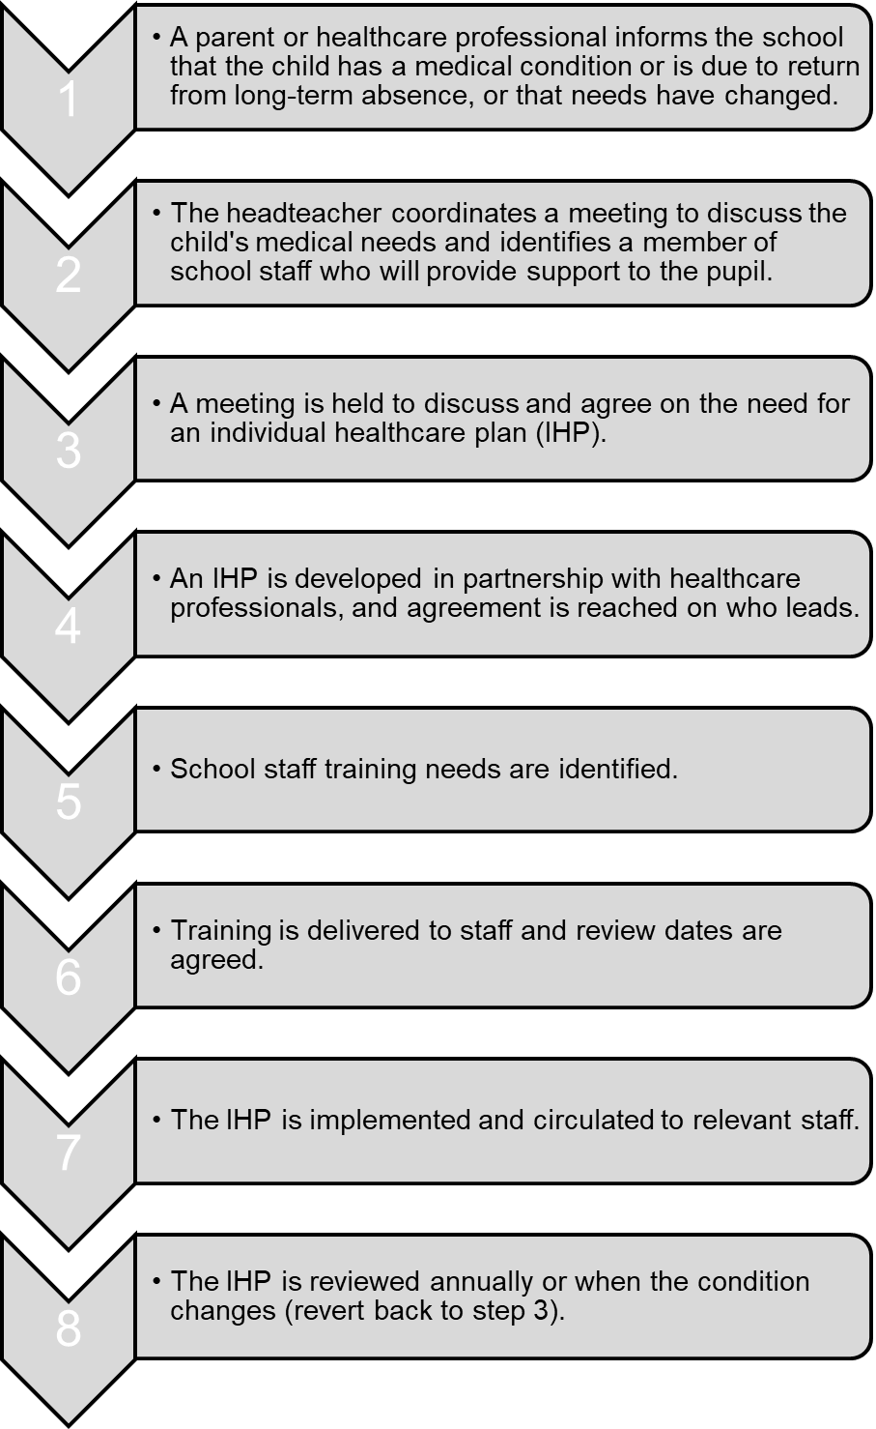

Incident Reporting Form
Date of incident | Time of incident | Place of incident | Name of ill/injured person | Details of the illness/injury | Was first-aid administered? If so, give details | What happened to the person immediately afterwards? | Name of first-aider | Signature of first-aider

