



Scargill CE Primary School Admissions Policy

For admissions from
September 2027 to August 2028

Approved by the Local Trust Committee:
- Introduction
Let all we do, be done in love.

Our Values & Aims
This is our school
Let love dwell here
Love of learning
Love of our community
Love of all people
Love of God
And love of life itself

Love of learning
We aim to:
- Encourage excellence
- Provide a safe and stimulating environment for learning
- Value the skills and talents of individuals
- Provide a broad, rich and relevant curriculum matched to every child’s needs

Love of community
We aim to:
- Forge many links with the wider community
- Be a responsive, responsible and tolerant community
- Look after our school and the global environment

Love of people
We aim to:
- Celebrate differences within our school community
- Promote respect and care for others as well as ourselves
- Handle conflict sensitively

Love of God
We believe it is important to:
- Meet together regularly to offer worship, praise, prayer and thanksgiving to God
- Know that we worship a God of love, justice, mercy and forgiveness
- Respect the beliefs of others

Love of life itself
- We celebrate the achievements of all.
- We foster a high level of self-esteem, believing that it is from this a truly positive love of life emanates.

Christian Values, British Values & Scargill Citizen Values

As a Church School, we maintain an ethos that is based on Christian values. We encourage children to behave and act in a way that matches these values. We also promote and encourage the British Values of:

- Democracy
- The rule of law
- Individual liberty
- Mutual respect for one another
- Tolerance of those of different faiths and beliefs.

We are proud to be a Church of England Primary School and part of the Derby Diocese Academy Trust. There are around 340 pupils in school, aged between 4 and 11. Our staff are committed to ensuring the best for every child and our school provides a vibrant and exciting curriculum for each individual to grow academically, personally and socially.

Our vision for excellence at Scargill is a safe and healthy learning environment where everyone is happy, excited, challenged and inspired to be a lifelong learner. We aim to do this within the context of a warm, welcoming, Christian ethos where our children further develop strong moral values.

The prospectus and website contain an overview of how the school operates and illustrates some of the opportunities that are available to our children. We are all extremely proud of our very special school family and would encourage prospective parents to come and meet our wonderful children and staff.

At Scargill, we value the partnership we have with our parents as we know that through working together, we can create a school where every child can flourish and reach their full potential.

At Scargill CE Primary School, we welcome all pupils, and places at the school are offered in an open, fair, clear and objective manner in accordance with the legal framework. We work to the principle that any parent accessing our admissions arrangements will be able to understand easily how places for our school will be allocated and will not be alienated or discouraged from applying based on admissions criteria.

DDAT is the Admissions Authority for school. All matters relating to admissions have been delegated and are carried out by the Local Trust Committee of Scargill CE Primary School on behalf of the Academy Trust.

The Local Authority will coordinate the admissions process on behalf of the trust, and parents will apply for a place through the Local Authority (see section 6).

Any objections in respect of the admissions arrangements not complying with the legal framework can be made to the Officer of the Schools Adjudicator.

- Legal framework

This policy has due regard to all relevant legislation and statutory guidance including, but not limited to, the following:

- Human Rights Act 1998
- School Standards and Framework Act 1998
- Equality Act 2010
- DfE (2022) ‘School Admission Appeals Code’
- DfE (2021) ‘School Admissions Code’

- Determining a Published Admissions Number (PAN)

The number of places available is determined by the capacity of the school. The PAN for new Reception pupils in 2027 is 60.

If the Local Trust Committee decides that it can accept more pupils than laid out in its PAN, it will notify the LA in good time so that the LA can deliver its coordination responsibilities effectively.

Where the number of applicants is less than the PAN then all children will receive a place. Where PAN has been reached then the oversubscription criteria will be applied. Any person with parental responsibility can appeal any refusal to admit to an Independent Appeals Panel.

- Oversubscription criteria

In the event that there are more applicants than available places, the school will apply the following oversubscription criteria, in order of priority given:

- Looked After Children (LAC) and previously LAC (PLAC), including those who have been in state care outside of England and ceased to be in state care as a result of being adopted or became subject to a child arrangement order or special guardianship order. IAPLAC - Internationally Adopted Previously Looked After Children. For children who were in state care outside of England and were then adopted, you must submit evidence with your application so this priority can be verified. The evidence must show your child's adoption (an adoption order or adoption birth certificate); and - that they were in state care outside England (a letter from the state).
- Children living in the normal area* served by the school at the time of application and admission who have siblings** attending the school at the time of application and admission.
- Children living in the normal area served by the school at the time of application and admission.
- Children not living in the normal area served by the school but who have siblings attending the school at the time of application and admission.
- Children of staff employed at the school for two years or more, or who will meet a skills shortage.
- Other children whose parents have requested a place.

All pupils who have named the school in their EHC plan will be admitted.

Definitions

* Normal area: As defined in the map included at Appendix A and at https://maps.derbyshire.gov.uk/connect/analyst/mobile/#/main?mapcfg=Ordnance_Survey_Maps (click on map legend (top right), select school catchment area, enter school name in field (top left hand side).

** Siblings include:
(a) a half-sibling
(b) a legally adopted/fostered sibling
(c) a step-sibling residing in the same family unit
(d) a child of parent’s partner living in the same family unit

Tie-Breaker

If there is a ‘tie-breaker’ between oversubscribed pupils, the school will allocate the place to the pupil who lives closest to school.

Distance will be measured from the front door of the child’s home address to the main entrance of the school using the Local Authority’s Geographic Information System. Those living closer to the school receive the higher priority. If the distance between two or more children’s houses and the school is the same, the allocation of the place will be made by the drawing of lots and independently verified.

Home Address

For admission purposes, the home address is the child’s permanent address, where the child usually lives with their parent or carer. Any other address should not be used on your application, including using the address of a childminder or relative or renting a property for a short period of time as this could be considered as using a fraudulent address. Any queries about addresses will be investigated and, depending on findings, the school place offer may change.

Only one address can be used on your application for a school place. Where shared care arrangements are in place, both parents must agree which address will be used on the application, and this should be the address where the child lives for the majority of the school week. If no joint declaration is received by the closing date for applications, the address where the child spends the majority of the school week will be used. In instances where the child spends equal time with each parent, the home address will be taken as the address where the child is registered with the doctor.

When an offer is made, it will be assumed that the address used in the application will be the same as the home address at the time the school place is taken up in September. If you plan to move house, you must still use your current address on your application. As soon as you move house, you must tell us your new address, providing proof of your house move (including evidence of entry to the new address and exit from the old address) as this may mean we have to change the school place offer.

If it is found that an intentionally misleading or false address has been given with the aim of fraudulently securing a school place, that place may be withdrawn, even if the child has already started at the school.

Attendance at the nursery does not guarantee a place in the primary school. A separate application form must be completed on transfer from the nursery to the primary school.

Infant Class Size Regulations

Infant classes (those where the majority of children will reach the age of 5, 6 or 7 during the school year) must not contain more than 30 pupils with a single qualified teacher. Additional children may only be admitted under very limited exceptional circumstances.

Deferred Entry

All places offered by the school will be offered on a full-time basis from the September following a child’s fourth birthday. Parents/carers can defer the date their child is admitted to the school until later in the school year but not beyond the point at which they reach compulsory school age and not beyond the beginning of the final term of the school year for which the offer was made.

Parents/carers may also request for their child to attend part-time until later in the school year but not beyond the point at which they reach compulsory school age.

Admission of children outside their normal age group

A request may be made for a child to be admitted outside of their normal age group for example if the child is gifted and talented or had experienced problems such as ill health. In addition, the parents of a summer born child (a child born between 1st April and 31st August) may request that the child be admitted out of their normal age group, e.g. to reception rather than year 1.

Parents should apply in the normal admission round and also submit a written request addressed to the Chair of the Local Trust Committee specifying why admission out of normal year group is being requested and the year group in which they wish their child to be allocated a place.

When such a request is made, the Local Trust Committee will make a decision on the basis of the circumstances of the case and in the best interests of the child concerned, taking into account the views of the headteacher and any supporting evidence provided by the parents.

If the request is agreed parents should then apply for a place in the Reception class in the September following the child’s fifth birthday in the normal admissions round for that year.

There is no right of appeal against a decision relating to admission out of chronological age.

Children of multiple births

Where the final place to be allocated within the Published Admission Number would separate children of multiple births a place(s) will also normally be offered to the other child/children.

Fair Access Protocols

Local Authorities are required to have Fair Access Protocols in order to make sure that unplaced children, especially the most vulnerable, are offered a place at a suitable school as quickly as possible. This includes admitting children above the published admissions number to schools that are already full. Children identified under the protocol will be admitted before any others on the waiting list.

- Consultation, determination and publication

Consultation

The Local Trust Committee will consult on any proposed changes to the admissions arrangements. Consultation will last for a minimum of six weeks and will take place between 1 October and 31 January in the determination year. The trust board will consult on admissions arrangements at least once every seven years, even if no changes have been made in that time.

Determination and publication of admissions arrangements

The Local Trust Committee will publish a copy of the full proposed admission arrangements and the contact details of the individual responsible for admissions liaison on the school website. A copy of the proposed admission arrangements will be made available upon request.

Admission arrangements will be determined by 28 February in the determination year on an annual basis, even when no changes to the arrangements have been made.

- Applications and offers

Applications

Parents will be provided with a common application form (CAF) by the LA where they will note their preferred schools, in rank order – the schools do not have to be located in the LA area where the parents live.

Application forms can made on-line via the LA website: www.derbyshire.gov.uk

Applications for a place must be submitted by: 15th January 2027.

The CAF will be submitted to the parents LA. Parents are not guaranteed to have their preferences met.

The Local Trust Committee will request supplementary information for the purpose of processing applications, where necessary. Failure to complete the school’s Supplementary Information Form may result in an application being ranked lower in the event of over-subscription as the application will be considered only on the basis of information available through the CAF.

The school will never give priority to applications solely on the basis that they have completed a supplementary form.

For previously LAC (PLAC) and LAC, the Local Trust Committee will request a copy of the adoption order, child arrangements order or special guardianship order, and a letter from the LA confirming that the child was looked after immediately prior to the order being made.

The school may request evidence that demonstrates a child was in state care outside of England prior to being adopted.

Allocating places

The Local Trust Committee will only allocate places on the basis of determined admissions arrangements. Any decisions to offer or refuse places will be decided by the Local Trust Committee or an admissions committee established by the Local Trust Committee. A clear record will be kept of all decisions made on applications, including in-year applications.

The Local Trust Committee will not refuse admission for a child solely on the basis that:

- They have applied later than other applicants.
- They are not of the faith of the school.
- They followed a different curriculum at their previous school.
- Information has not been received from their previous school.

Pupils not of usual school age will not be given less of a priority where the school is oversubscribed.

In the event that parents of a child wish for their child to be admitted outside their normal age group, the school’s headteacher will assist the Local Trust Committee in deciding on which year group the child will enter. Once a decision has been reached, the child’s parents will be informed in writing along with an explanation of how the decision was reached and any reasons why.

Service personnel and crown servants

For children of UK service professionals and crown servants, the following procedure will be adhered to:

- A place will be allocated to the child in advance of the family arriving in the area named in the application form, where one is available.
- The application must be accompanied with an official letter confirming the relocation date.
- The address at which the child will live will be used when considering the application against the oversubscription criteria – a Unit or quartering address must be used where this is requested by the child’s parents.
- The application will not be refused on the grounds of the child not currently living in the area or not currently having an intended address, nor will places be uniquely reserved.
- The arrangements for service children will be in line with the government’s commitment to removing disadvantage for service children.

Special Educational Needs

The school must admit all children who have an EHC plan where the school is named. Children with SEND who do not have an EHC plan will be treated equally to all other applicants in the admissions process. This includes children who may need extra support or reasonable adjustments to be made. The details of the school’s SEND provision can be found in the Special Educational Needs and Disabilities (SEND) Policy and SEN Information Report available on the school website.

Offers

All offers will be made on National Offer Day, i.e. 16 April or the next working day where this date falls on a weekend or bank holiday.

Where the school is oversubscribed, the Local Trust Committee will rank applications in accordance with the determined arrangements, and will ensure that only one offer will be made per child by the LA.

Withdrawing an offer

An offer will be withdrawn if it has been made in error, or if the offer was made via a fraudulent or misleading application. If any application is found to be fraudulent after a child has started at the school in the first term of the new academic year, the school may withdraw the place. If the fraudulent application is found after this time, the pupil will not be removed.

- In-year admissions

The school will follow the same process for in-year admissions as for admissions at the start of the academic year.

The Local Trust Committee will publish in-year arrangements on the school website by 31 August each year, detailing how applications will be dealt with between 1 September until the following 31 August. These arrangements will set out how parents can apply for a school place.

Where the school has places available in-year, it will offer a place to every child who has applied for one without condition or use of oversubscription criteria, unless to do so would be to prejudice the efficient provision of education or use of resources.
Applications can be made in year to the LA – instructions on how to do this are provided on the Local Authority website: www.derbyshire.gov.uk

All such applications will be considered and if the year group applied for has space available, then a place will be offered. If a place is not available, then the child’s parents can ask for their child’s name to be added to the appropriate waiting list. As with admissions at the start of the academic year, parents whose applications are turned down are entitled to appeal through the process outlined below.

The LA will notify all parents within 15 school days of receipt of an in-year application of the outcome of this application.

Where an offer is accepted, the school will make arrangements for the pupil to start as soon as possible.

LA in-year coordination scheme

The school will inform the LA by 1 August of whether it will participate in the LA’s in-year coordination scheme and will send any relevant information for the LA to publish on its website.

Where the school is participating in the LA coordination scheme, the school will provide the LA with details of the number of places available no later than two school days following the request of such information from the LA. The school will also provide information to parents about how they can find details on the relevant scheme.

- Waiting list

For admissions at the start of the academic year, the school will operate a waiting list which is maintained until 31 December on year of entry. The list will set out the priority for places in the same order set out in the oversubscription criteria. When additional children are placed on the waiting list, the list will be re-ordered in line with the oversubscription criteria – no pupil will be prioritised based on when their name was added to the list.

The Local Trust Committee will make clear in the admissions arrangements the process for requesting admission outside of the normal age group for the admissions round.

Parents may request that their child is placed on the waiting list if they are not successful in receiving a place. Where a place becomes available, it will be offered to the parents of the child at the top of the list.

For in-year admissions, if there is a waiting list for that year, the child will be placed on a waiting list until a space becomes available, or the child finds a new school setting. The list will set out the priority for places in the same order as admissions at the start of the year – when a place becomes available, it will be offered to the parents of the child at the top of the list.

If a child on the waiting list is offered a position at the school, the parents will be notified by letter and will have the option of accepting or rejecting the place.

- Admissions appeals

When informing parents of their unsuccessful admissions application, a letter will be sent which includes the reason why admission was refused; information about the right to appeal; the deadline for lodging an appeal and the contact details for making an appeal. Parents will be informed in the letter that, if they wish to appeal, they must make the appeal in writing. Grounds for appeal are not limited.

Appeals hearings

The Local Trust Committee will publish an appeals timetable on the school website by 28 February each year. The timetable will comply with section three of the ‘School Admission Appeals Code’. Appeals will be lodged and heard for the normal admissions round within 40 school days of the deadline for lodging appeals.

For late applications, appeals will be heard within 40 school days from the deadline for lodging appeals where possible, or within 30 school days of the appeal being lodged. For in year admissions, appeals will be heard within 30 days of the appeal being lodged.

Complaints

Appellants do not have the right to more than one appeal in respect of the school for the same academic year unless, in exceptional circumstances, the Local Trust Committee has accepted a second application from the appellant due to a material change in the circumstances of the parents, child or school but still refused admission. Appellants can apply for a place at the school for a different academic year. If appellants have an issue with the appeal process, they can complain to the Secretary of State.

Appendix A

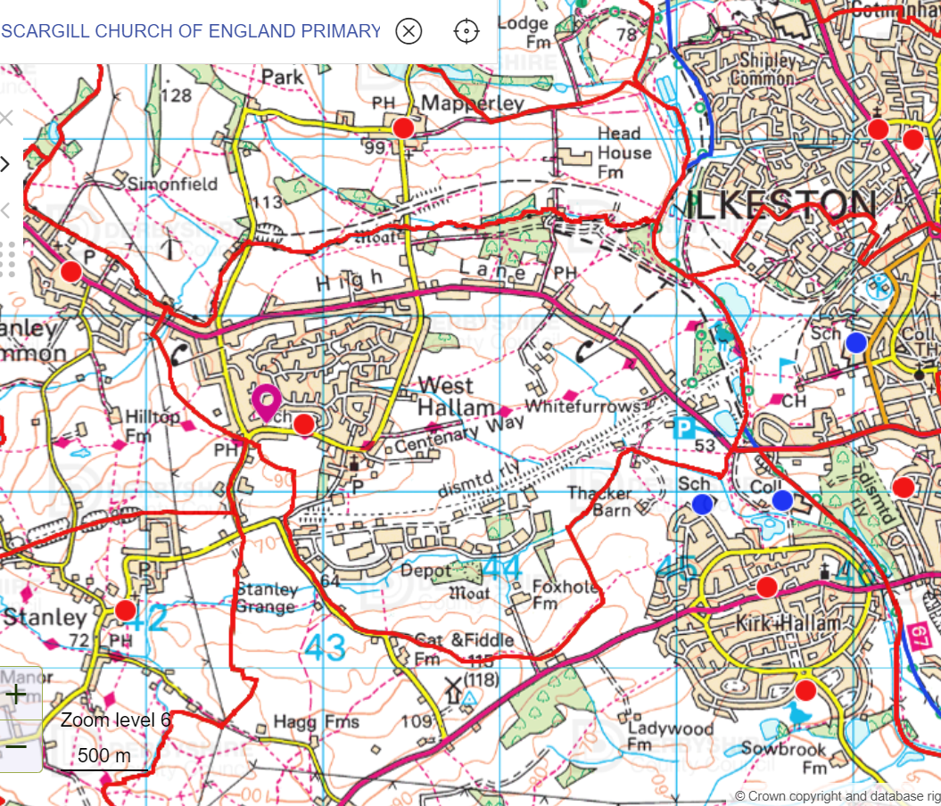

A more detailed map can be found here:
https://maps.derbyshire.gov.uk/connect/analyst/mobile/#/main?mapcfg=Ordnance_Survey_Maps (click on map legend (top right), select school catchment area, enter school name in field (top left hand side).

