

Scargill Church of England Primary School

**Marking and Feedback Policy**

|  |  |  |  |
| --- | --- | --- | --- |
| Signed by: | | | |
|  | Headteacher | Date: |  |
|  | Chair of governors | Date: |  |

Next review date: June 20234

**Contents:**

**1. Statement of Intent**

**2. Legal Framework**

**3. What is the purpose of assessment?**

**4. What is the purpose of feedback?**

**5. Responsive and effective teaching and learning**

**6. Continual formative assessment and feedback during all lessons**

**7. Whole Class Feedback Chart**

**8. Written feedback i.e. marking after the learning**

**1. Statement of Intent**

Scargill Church of England Primary School understands that *responsive* teaching and learning is underpinned by an evidence-informed approach to assessment and feedback.

Consistent assessment and feedback at Scargill C of E Primary School is an integral part of the high quality teaching and education that takes place in all of our classrooms, across all age ranges. This policy provides clear guidance to all staff (teachers, TAs and HLTAs) on the purpose, types and frequency of assessment and feedback which we use so we ensure all of our children ***know***, ***experience***, ***remember*** and ***do*** more.

It is important to state that assessment and feedback adds little unless the teaching is effective.

**2. Legal Framework**

2.1 This policy has due regard to statutory legislation, including, but not limited to, the following:

* Teachers’ Standards: The standards themselves (part 1 and part 2) have statutory force (under regulation 6(8)(a) of the Education (School Teachers’ Appraisal) (England) Regulations 2012).
* SEND Code of Practice (2015)

2.2 This policy is intended to be used in conjunction with the SEND, EYFS & all subject policies and procedures.

2.3 This policy has been developed upon action research which includes:

* Fletcher-Wood, H. (2018) *Responsive teaching* (Abingdon: Routledge)
* Hattie, J. (2012) *Visible Learning for teachers* (Abingdon: Routledge)
* Percival, P. (2017) No written marking. Job Done. [Blog] onebetweentwo Available at: <http://primarypercival.weebly.com/blog/no-written-marking-job-done>
* Sealy, C. (2018) *How we stopped marking* [Blog] DfE Teaching Blog. Available at: <https://teaching.blog.gov.uk/2018/07/23/how-we-stopped-marking/>
* Sealy, C. (2020) *How The New No Marking Policy For Our Primary School Works* [Blog] Third Space Learning. Available at: <https://thirdspacelearning.com/blog/new-no-marking-policy-confessions-primary-headteacher/>
* Sherrington, T. (2016) *Rethinking marking and feedback. It’s all about the response.* [Blog] TeacherHead. Available at: <https://teacherhead.com/2016/10/09/rethinking-marking-and-feedback-its-all-about-the-response/>
* Wiliam, D. (2018) *Embedded formative assessment* (Indiana: Bloomington)
* Wiliam, D. (2018) *Dylan Wiliam on workload* [video]. Available at: <https://www.youtube.com/watch?v=tPmCGwM3gtw&safe=active>

**3. What is the purpose of assessment?**

Purposeful assessment is at the heart of all highly effective teaching and learning.

Our staff use multiple assessment methods to provide rapid formative interpretations and make adjustments to their teaching to improve learning.

Well planned and carefully designed assessments, including RRR (Revisit, Remember & Respond) are also used to increase long-term memory as children ‘practice retrieving things from memory (retrieval practice)’ (Wiliams 2018).

**4. What is the purpose of feedback?**

* The sole focus of feedback should be to further children’s progression through the curriculum.
* Evidence of feedback is incidental to the process; we do not provide additional evidence for external verification.
* Feedback should empower children to take ownership for improving their work; adults should not be doing the work for the pupil.
* Written comments should only be used as a last resort for the very few children who otherwise are unable to locate their own errors, even after guided modelling by the teacher.
* Children should receive feedback either within the lesson itself or in the next appropriate lesson. The ‘next step’ is usually the next lesson.
* New knowledge is fragile and usually forgotten unless explicit steps are taken over time to revisit and refresh learning. Teachers should be wary of assuming that children have securely understood material based on evidence drawn close to the point of teaching it. Therefore, teachers will need to get feedback at some distance from the original teaching input when assessing if learning is now secure.

Our staff should provide rapid and effective feedback, appropriate to our understanding of the child’s learning and needs, and then seek evidence that the feedback is received and used.

**5. Responsive and effective teaching and learning**

Continual assessment and effective feedback are integral to highly effective learning.

**6. Continual formative assessment and feedback during all lessons**

**7. Whole Class Feedback Chart**

The Whole Class Feedback Charts will identify common trends, errors or misconceptions which will then need to be addressed by well planned, responsive teaching. There is no expectation that these quadrants are used for every lesson. The ‘next step’ for most children is usually the next carefully planned lesson. Use Whole Class Feedback Chart at the start of lessons to address misconceptions from the previous lesson. (When appropriate, across all curriculum areas). Feedback chart for Maths and English – Appendix A. Feedback chart for other subjects – Appendix B. The charts will be kept in teachers’ planning file and be available to be viewed during monitoring activities.

**8. Written feedback i.e. marking after the learning**

Marking is just one tool for highly effective teaching and learning. Marking can ‘*provide important feedback to pupils and help teachers identify pupil misunderstanding*’ (EEF 2016: 4). However, we are aware that all too often the time spent marking could be used more purposefully to plan and support the immediate and appropriate precise, next steps for our children. This is because we know that written feedback needs to ‘*focus on what’s next, rather than focusing on how well or poorly the child did on the work*’ (Wiliams 2018: 143).

Consequently, all staff should rapidly respond to the children’s needs during the lessons, so that learning can be improved during every lesson. This means staff need to provide feedback throughout all lessons.

Written feedback still occurs and is undertaken to:

* *To reinforce learning and expectations*: Sometimes there are ‘non-negotiables’ which children have forgotten. If the child is reminded about this in a piece of work, an improvement is expected the next time that child’s work is marked.
* *identify errors resulting from misconceptions*: We provide hints or questions which lead pupils to underlying principles. All staff mark in green pen. Corrections might be indicated by a sticky tag and are usually completed in purple pen by the child. Staff will check to see whether this answer is correct and mark accordingly.

It is important that all corrections undertaken in purple pen are completed in line with our presentation expectations. Staff always need to model clear expectations and address standards which are not in line with our agreed expectations.

It is therefore vital that staff are familiar with expectations from current and previous year groups.

**Marking is, crucially, used to inform learning** (Teachers’ Standard 6: Make accurate and productive use of assessment).

**All staff mark and plan using the following approach:**

* **A focused WALT based upon Age Related Expectations from our curriculum**

All staff are to highlight the WALT after a lesson to assess whether the child has achieved work at one of the following stages:

* Yellow highlight work at WTS: working towards the lesson objective
* Green highlight work at EXS: achieved the lesson objective

EYFS & KS1 Marking Code for Maths: (Used for targets, praise and reminders)

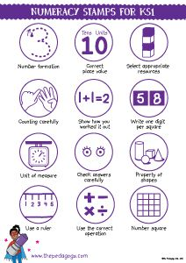

NB EYFS use only number formation & count carefully stampers.

EYFS & KS1 Marking Code for English:

[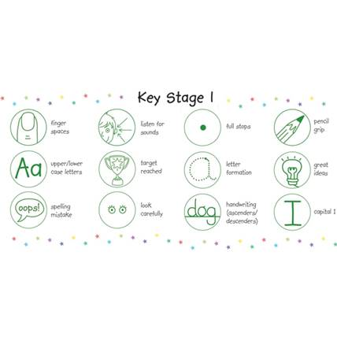](http://www.google.co.uk/url?sa=i&rct=j&q=&esrc=s&source=images&cd=&cad=rja&uact=8&ved=0ahUKEwjB3ZOggZ3MAhWMnRoKHepXBfsQjRwIBw&url=http://www.primaryteaching.co.uk/products/pm001/box-of-12-pedagogs-ks1-marking-stampers-free-refill-ink&psig=AFQjCNEWpKeJqgh2RQ8o4KllPVLQcLrMjg&ust=1461234603535497)

**Staff must ensure that they are also promoting accuracy and presentation in all written work**

All staff need to model the expected handwriting style and expectations when modelling any type of writing, either on boards or when writing in the children’s books. This will be using:

R - Print

Y1 – Pre-cursive

Y2 - joined

Y3-6 – joined

Appendix A

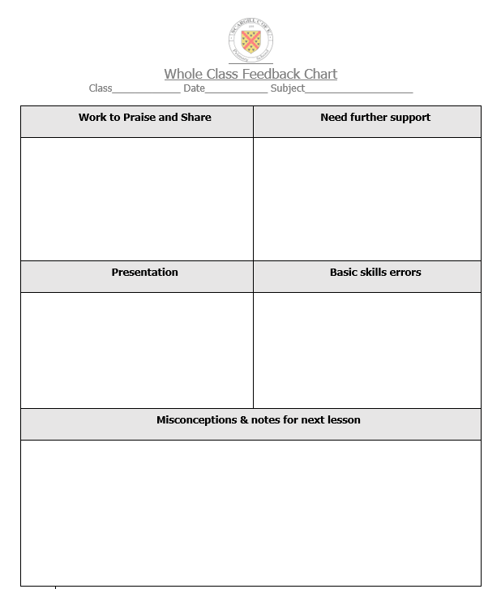

Example of completed chart

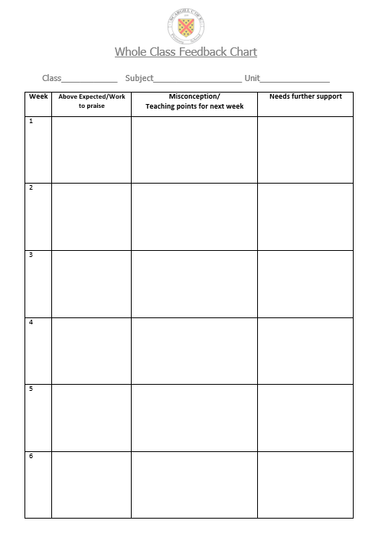Appendix B