**The Great Scargill Bake Off**

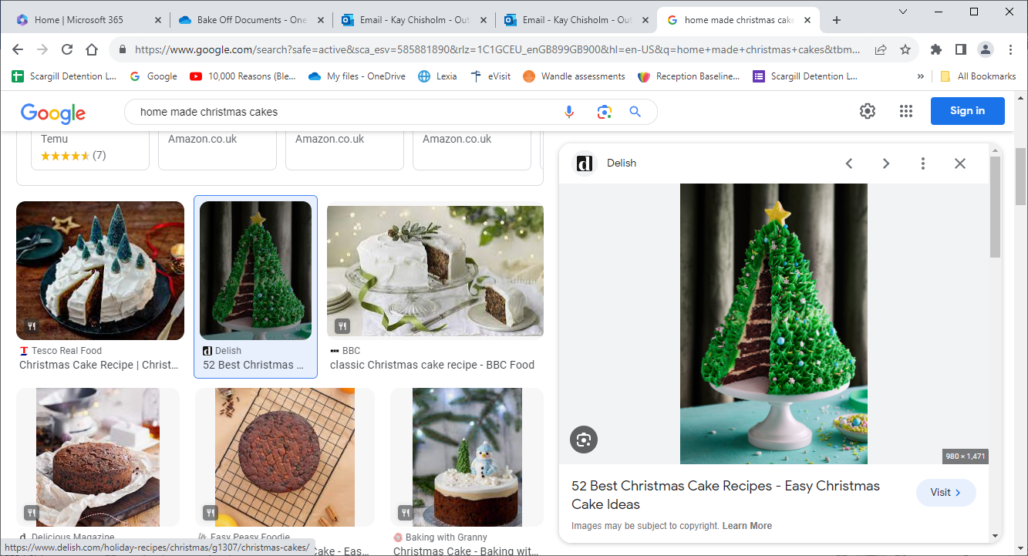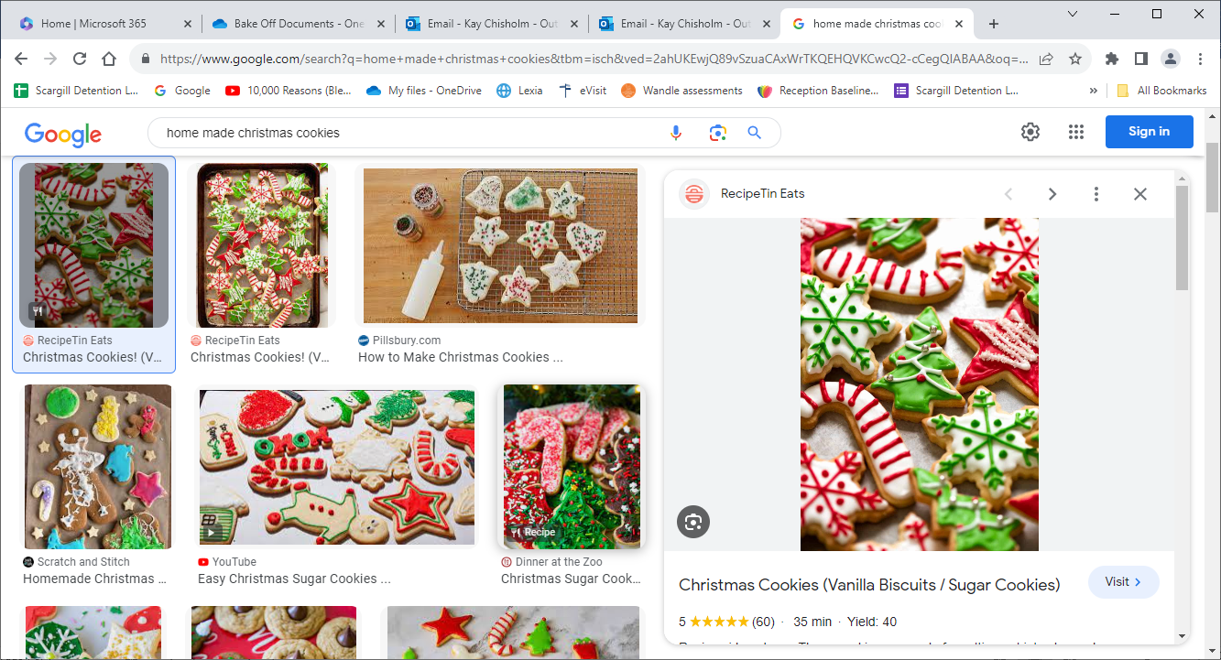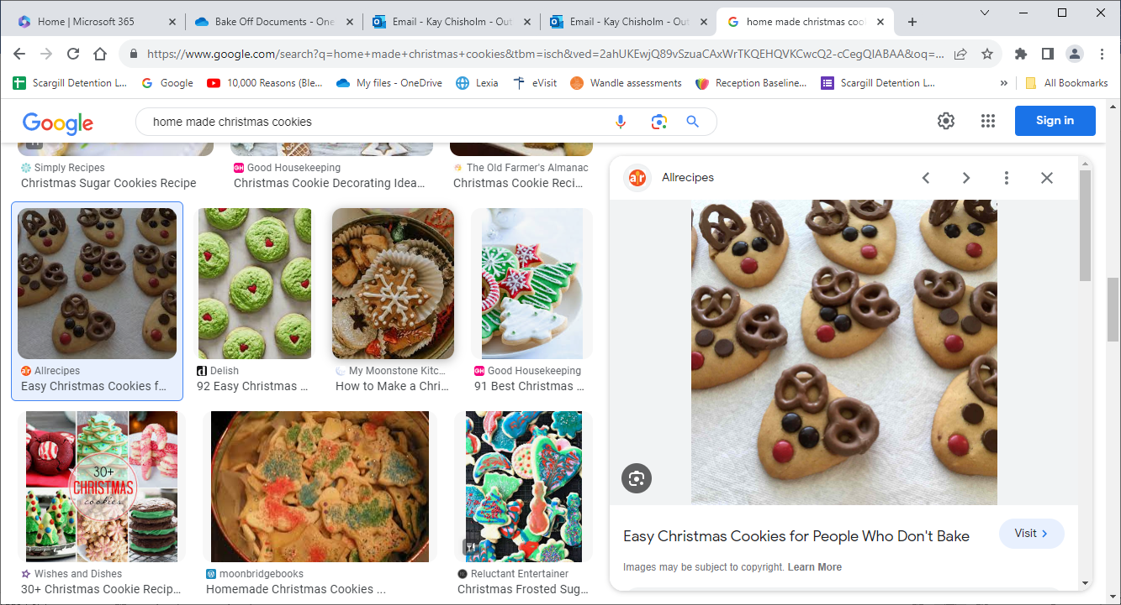

**How to enter:**- Take an entry slip  
 home.  
- Design your biscuit or  
 cake.

- Get baking.  
- Bring your entry and slip in on December 15th 2024.

**Calling all bakers: Can you design and bake festive cookies or cakes? We are judging the final designs by decoration.**

**(No nuts please)**

**Prize Categories:**  
- Reception.  
- Year 1 & 2.  
- Year 3 & 4.  
- Year 5 & 6.

Best design by appearance in each category as voted by the School Council.

**Cakes will be sold at the School Fayre.**